**Development of Chemical Lab Using Oculus Virtual Reality**

Duan Xiao Yun

**Abstract**

Virtual Reality technology have open a vast opportunity to be applied in many fields include education. This paper is based on a research of the conventional chemistry experiment education limitations, we design and developed a "Virtual Chemistry Lab" propose a new method of assisting present teaching aids. Take the “Magnesium ribbon combustion” experimental process as a demo, implementation of this application achieved the education objective more effectively.

*Keywords: Virtual Reality, Argument Reality, Chemistry experiment, Educational application*

**1 Introduction**

VR Chemistry Lab is an educational experience that can virtually simulate lab procedures and important lab safety measures. Users are immediately immersed inside a VR laboratory and can use the Oculus HMD or LeapMotion to interact with the environment. the lab equipment on the table can be picked up, placed, thrown, or used in experimental procedures. Through virtual experiment, students can perform simulation experiments in an environment closest to real, familiarize with the experimental process, observe and record experimental phenomena, save reagents, reduce danger, and achieve the goal of learning at anytime and anywhere.

**1.1 VR technologies**

Virtual Reality(VR) that uses a computer that creates a simulated 3D world. Jerald. et al, [1] presented that VR is defined as “a computer-generated digital environment that can be experienced and interacted with as if that environment were real” and asserted that VR is communication, they emphasized the importance of human factor that influence the interaction between the VR system and the users [2]. VR technology mainly refers to the three-dimensional VR based on head-mounted equipment. This technology could actualize kind of immersive 3D experiential effects by offering users different images of one object from two perspectives. Shown in Fig.1.

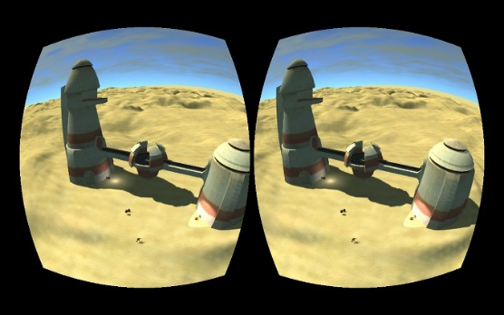

Fig.1. Separated images displayed in the Oculus Rift [3]

Since 2014, Oculus, HTC Vive, Gear VR, etc. have a booming development, VR applications are spread in our life such as game, education, traveling and many other fields. In this paper we use Oculus HMD which is connected to PC and Gear VR which is connected with smartphone.

**1.2 Limits in Conventional Chemistry Education**

The conventional chemistry experimental education is primarily passive or receptive learning style. First: Lack of motivation and of activity, students are shown the experiments results instead of probing the results. Second: Temporal and spatial constraints; students cannot do the experiments anytime and anywhere for the limits of objective conditions and cannot repeat the experiment steps. Third: Wasted reagents and danger, some of the reagents are dangerous, therefore many practices are requisite before using the real ones. In this way can save the reagents and lessen the danger. Besides, compare to the general 2D chemistry applications it guarantees the immersion almost alike the real world, users can see and interact with the microcosmic things like molecular structure, All the solutions are confirmed Improved learning efficiency.

**3 Implementation**

**3.1 Project Design**

The “Magnesium ribbon combustion” experimental principles and reaction equations involved are as follows:

2Mg + O2——ignite——2MgO  (1)

Mg + 2CH3COOH——(CH3COO)2Mg + H2(↑） (2)

2CH3COOH + MgO=(CH3COO)2Mg + H2O (3)

Eq (1) Magnesium is ignited under oxygen generate magnesium oxide. Eq (2) Magnesium Rod produces Magnesium acetate and Hydrogen in acetic acid solution. Eq (3) Magnesium oxide produces magnesium acetate and H2O in acetic acid solution.

**3.2 Project Implementation**

Using the Oculus HMD and Touch Controllers, Users Grab the Matchstick by the ring fingers, and fire the [alcohol](javascript:;) [lamp](javascript:;) by putting the matchstick on it, shown in Fig.3. and then grab the magnesium ribbons and put it on the fire. Put both fired magnesium ribbon and unfired magnesium ribbon into the breakers that are filled with [acetic](javascript:;) [acid](javascript:;). Then users can observe the [experimental](javascript:;) [phenomenon](javascript:;) and extinction the Alcohol lamp fire by putting the cover on it.

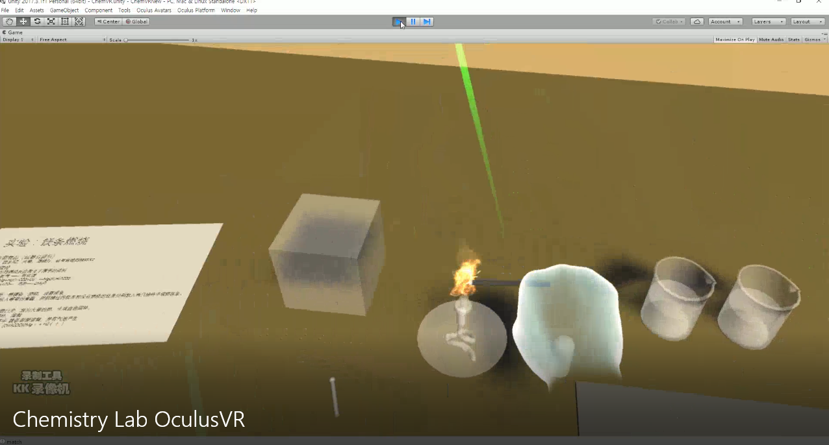

Fig.3. Project Implementation using Oculus

**4 Conclusion**

Students can have better study experience in MR Environment. The VR hardware devices such as OCULUS Set is expensive and still have technical problems (vertigo). The LeapMotion can interact more naturally but low accuracy and sensibility. Compared with VR. The way of its combination with specific educational content needs to be designed with more efforts and time.

**References**

[1] The Virtual Lab (Physics & Chemistry) for Malaysia’s Secondary School [accessed Oct 3, 2017].

[2] Jerald, J. (2015). The VR book: Human-centered design for virtual reality. Morgan & Claypool.

[3] Dave Wyand (2013), Torque 3D Now Supports the Oculus Rift. URL: http://www.garagegames.com/community/blogs/view/22249

[4] Parisi, T. (2015). Learning virtual reality: developing immersive experiences and applications for desktop, web, and mobile. "O'Reilly Media, Inc."